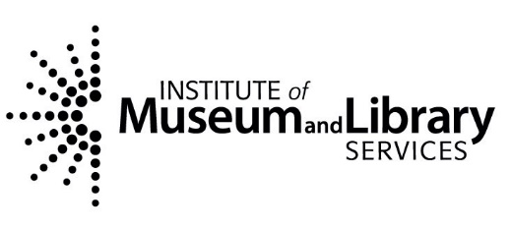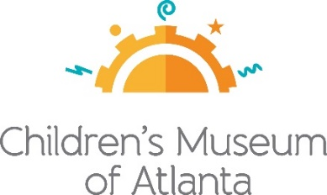

FOR MORE INFORMATION
Sarah Wynn Benton
BRAVE Public Relations
404.233.3993
sbenton@emailbrave.com

FOR IMMEDIATE RELEASE

The Institute of Museum and Library Services Awards more than $200,000
to Children’s Museum of Atlanta
Atlanta cultural organization cites plans for IMLS grant

ATLANTA – (Feb. 10, 2023) – Children’s Museum of Atlanta announces it has been selected to receive a $210,306 grant from The Institute of Museum and Library Services (IMLS) through its Museums for America special initiative. This initiative supports projects that will aid in strengthening the Museum to benefit Atlanta by providing high-quality, inclusive learning experiences, maximizing resources to address community needs through partnerships and collaborations and by preserving and providing access to the collections entrusted to their care. This is the second time the Museum has been selected for this grant. Working hand in hand with Georgia State University, the Museum will make way for curriculum specific virtual education for underserved students in the Atlanta area.

“Here at the Children’s Museum of Atlanta, we do everything in our power to continue building upon service and learning elements for our visitors,” said Executive Director Edwin Link. “We are extremely grateful The Institute of Museum and Library Services selected us to receive these funds, which will help our organization continue fostering relationships with the community and our partners.”
The Museum will collaborate with Georgia State University to provide preschool, Pre-K, kindergarten and special needs students from rural and urban Title I public school systems with curriculum-directed virtual learning opportunities. Teachers and Museum education staff will receive training on approaches to facilitate and provide digital literacy lessons to students and how to assess students’ academic progress. University research professors will work with Museum team members to develop and implement a research based pre- and post-assessment program to evaluate the effectiveness of virtual programming on students’ learning outcomes. The results from these evaluations create an assessment tool that the Museum will share with other institutions in the state and nationwide. This project will address the digital divide by creating an innovative, play-based curriculum for virtual learning that will improve language and literacy skills for all types of students.

###

About The Institute Museum and Library Services:
The Institute of Museum and Library Services is the primary source of federal support for the nation's libraries and museums. We advance, support, and empower America’s museums, libraries, and related organizations through grantmaking, research, and policy development. Our vision is a nation where museums and libraries work together to transform the lives of individuals and communities. To learn more, visit www.imls.gov and follow us on Facebook and Twitter.

About Georgia State University partners:
CMA will partner with Georgia State University professors to study program implementation, analysis, and outcomes. Dr. Gary Bingham is a professor in the Department of Early Childhood and Elementary Education at Georgia State University. His research examines home and school factors that contribute to the academic achievement of culturally and linguistically diverse children. Dr. Rihana Mason received her Ph.D. in experimental psychology with an emphasis in cognitive psychology from the University of South Carolina, Columbia, SC in 2004. Her primary research interests include vocabulary acquisition, reading comprehension, and the assessment of language and literacy in diverse populations.
About Children’s Museum of Atlanta:
Children’s Museum of Atlanta is the only educational venue of its kind in Atlanta, presenting educational programs and exhibits designed for young children ages 0-8. The mission of Children's Museum of Atlanta is to change the world by sparking every child's imagination, sense of discovery and learning through the power of play. With learning zones consisting of bright, creative and hands-on exhibits, the Museum supports inventive play-based exploration and experiential learning focused on the whole child. Core competencies for literacy, math and science are promoted throughout all exhibits and programming in alignment with the state and national Core Performance Standards. Funding has been provided by Georgia Humanities and the National Endowment for the Humanities as part of the American Rescue Plan Act of 2021. For more information, please visit GeorgiaHumanities.org. Major support is provided by the Mayor's Office of Cultural Affairs and major funding is provided by the Fulton County Board of Commissioners. Children’s Museum of Atlanta also offers memberships. For more information or to support Children's Museum of Atlanta, visit childrensmuseumatlanta.org or call 404.659.KIDS [5437].

